MORE QUERIES ON BANK DATABASE

SELECT DISTINCT D.Customername

FROM Depositer AS D

WHERE NOT EXISTS (

SELECT B.Branch_name

FROM Branch AS B

WHERE B.Branch_city = 'Bangalore'

AND B.Branch_name NOT IN (

SELECT A.Branch_name

FROM BankAccount AS A

JOIN Depositer AS T

ON A.Accno = T.Accno

WHERE T.Customername = D.Customername

)

);

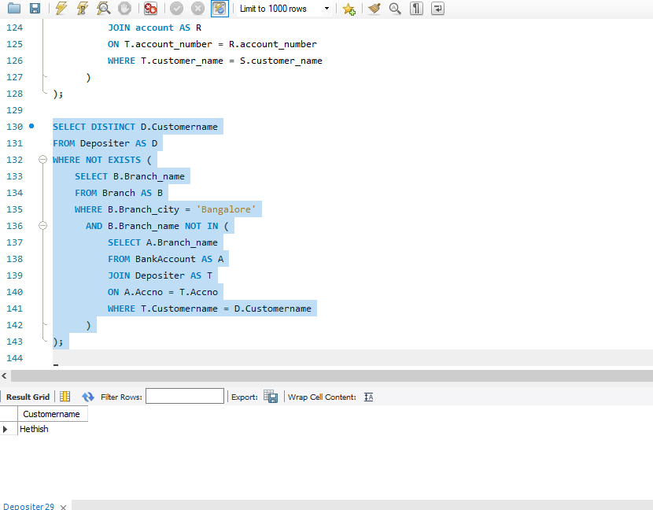

2. SELECT DISTINCT b.Customername

FROM Borrower AS b

WHERE b.Customername NOT IN (

SELECT d.Customername

FROM Depositer AS d

);

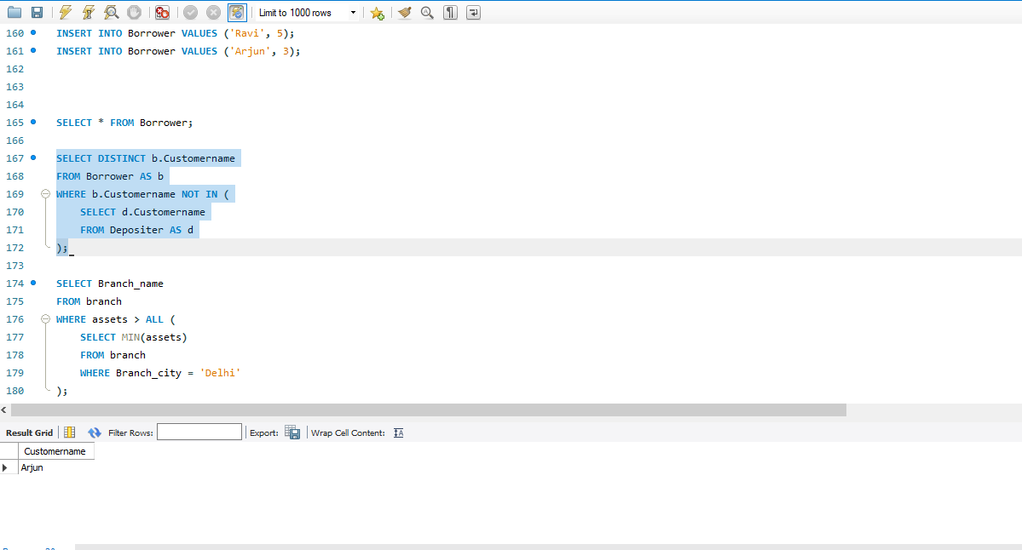

3. SELECT Branch_name

FROM branch

WHERE assets > ALL (

SELECT MIN(assets)

FROM branch

WHERE Branch_city = 'Delhi'

);

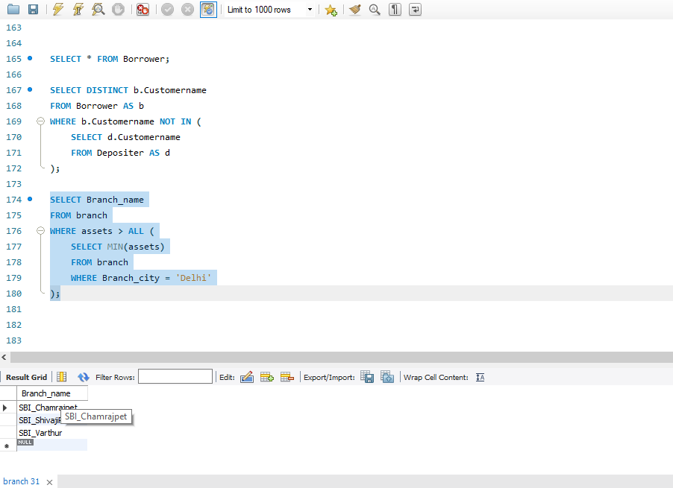

4. SELECT DISTINCT b.Customername

FROM Borrower AS b

JOIN Loan AS l ON b.Loan_number = l.Loan_number

JOIN BankAccount AS a ON a.Branch_name = l.Branch_name

JOIN Depositer AS d ON d.Accno = a.Accno AND d.Customername = b.Customername

WHERE a.Branch_name IN (

SELECT Branch_name

FROM Branch

WHERE Branch_city = 'Bangalore'

);

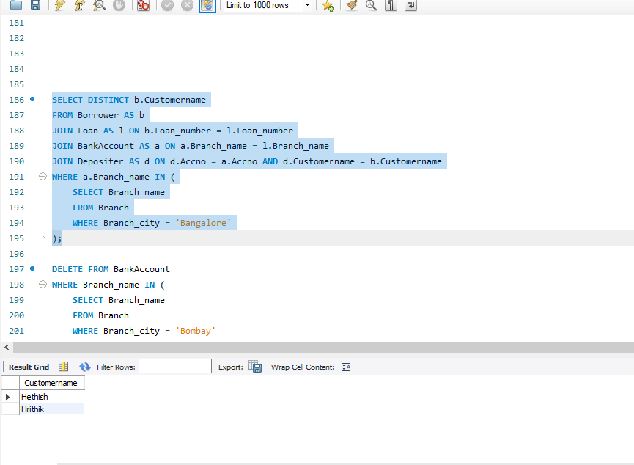

DELETE ALL ACCOUNT TUPLES AT EVERY BRANCH LOCATED IN A SPECIFIC

CITY :

DELETE FROM BankAccount

WHERE Branch_name IN (

SELECT Branch_name

FROM Branch

WHERE Branch_city = 'Bombay'

);

5. SELECT * FROM LOAN ORDER BY AMOUNT DESC;

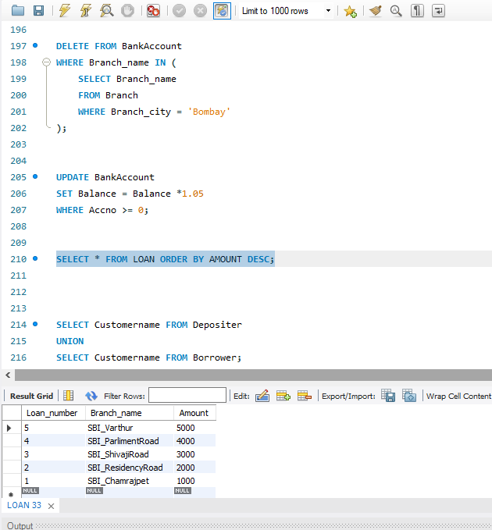

6. SELECT Customername FROM Depositer

UNION

SELECT Customername FROM Borrower;

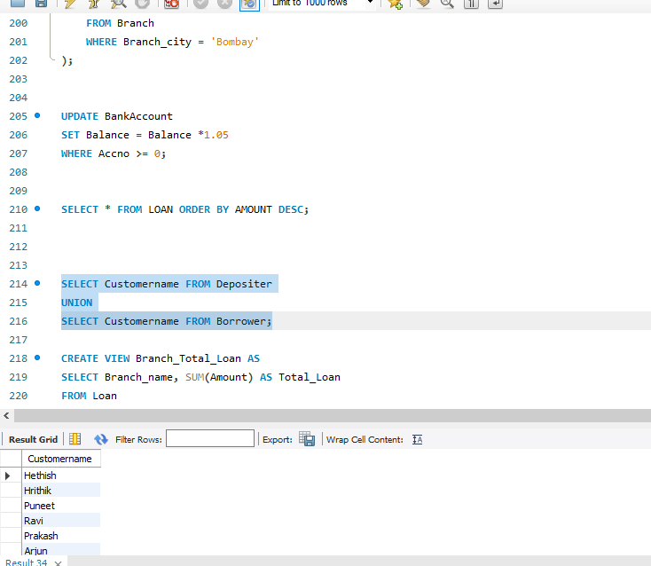

7. CREATE VIEW Branch_Total_Loan AS

SELECT Branch_name, SUM(Amount) AS Total_Loan

FROM Loan

GROUP BY Branch_name;

SELECT * FROM Branch_Total_Loan;

